Asia-China-Coin Collection 3

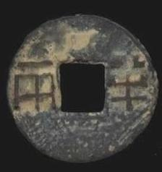The 1st coin(from left to right): "Ban Liang" (half teal)  Qin Dynasty: The Qin Ban Liang (half teal) coins, in a round-with-a-central-square-hole form, became a national legal currency since the first emperor united the country (221 BC). The denomination "Ban Liang" refers to its weight.

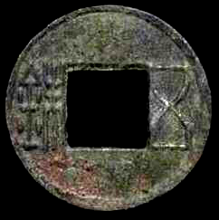The 2nd coin: "Wu Zhu" (five Zhu) : Han Dynasty(BC206-220AD):  "Wu Zhu" coins were about 3 gram each, were cast in the Wudi reign period (140-135BC) of the Han dynasty.As the denomination met well the needs of circulation, it was continuously used till the Sui dynasty (581-618).

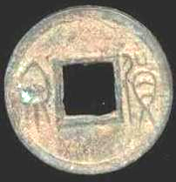The 3rd coin:"Huo Quan"  Xin Dynasty (9-20)

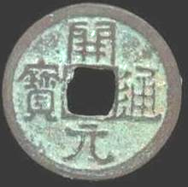The 4rd coin: "Kai Yuan Tong Bao"  Tang Dynasty(618-907): In 621, the 4th year of Tang Emperor Wude, "Kal Yuan Tong Bao" coins were formally issued and the former "Wu Zhu" coin system was abolished. As the major currency of the Tang dynasty, each "Kai Yuan Tong Bao" coin weighed one-tenth Liang (tael, each tael then equals 42 gram), which began the decimal system in ancient China. "Tong Bao" and "Yuan Bao" were the names of money.

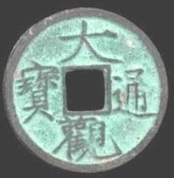The 5th coin: "Da Guan Tong Bao"  It was casted in 1101-1125.The four Chinese charaters on the coin were written by Huizong,the last emperor of the Northern Song.He was also an outstanding calligrapher in history.

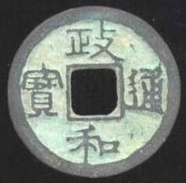The 6th coin: "Zheng He Tong Bao"(1111-1118) Official Script  Song Dynasty(960-1279)  
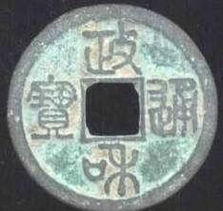The 7th coin: "Zheng He Tong Bao"(1111-1118) Seal Script  Song Dynasty(960-1279)

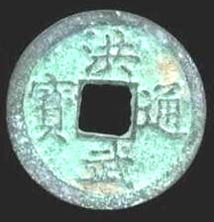The 8th coin: "Hong Wu Tong Bao" It was casted by the first Emperor of Ming Dynasty(1368-1644)

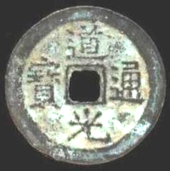The 9th coin:"Dao Guang Tong Bao"  Qing Dynasty(1616-1911 AD)

# Zhi Da Tong Bao (1310-1311)-Yuan Dynasty

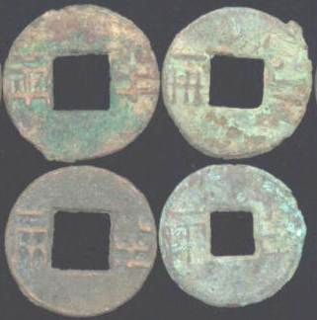

"Ban Liang" (half teal) : Qin Dynasty: The Qin Ban Liang (half teal) coins, in a round-with-a-central-square-hole form, became a national legal currency since the first emperor united the country (221 BC). The denomination "Ban Liang" refers to its weight.These Ban Liang coins were casted,after Qin Dynasty, in Han Dynasty(206 BC-220 AD).

Diameter:about 23mm     Material:Bronze